**PERSONAL BLOG ON IBM CLOUD STATIC WEB APPS**

**PROBLEM STATEMENT:**

Create a personal travel blog hosted on IBM Cloud Static Web Apps. Share your travel adventures, tips and captivating photos with the world. Use IBM Cloud Static Web Apps to easily update your blog and document your journeys. Inspire others to explore the beauty of the world and forge unforgettable memories!

**PROJECT OBJECTIVE:**

The primary goal of our travel blog is to inspire and empower people to explore the world, discover new cultures, and create unforgettable memories through travel. Our target audience includes travel enthusiasts, adventure seekers, and anyone who shares a passion for exploring new places and experiences.

**DESIGN THINKING:**

Design thinking is an approach when it comes to creating a travel blog hosted on IBM Cloud Static Web Apps. The main goal is to inspire and empower travel enthusiasts and adventure seekers. To achieve this we start by understanding our target audience's desires and challenges through empathy map.

The empathy map that was designed for the travel blog is given below,

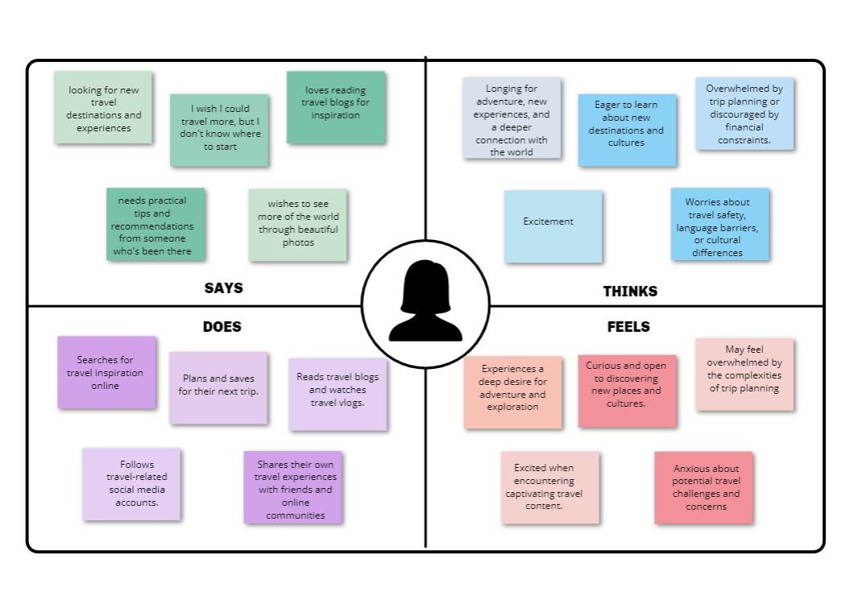

The design thinking involves the following,

* Content Planning
* Content Creation
* Website Setup
* IBM Cloud Setup
* Content Management System

We brainstorm design ideas and think about the user experience. We aim to incorporate features, like maps and immersive photo galleries to enhance the experience. After ideation we create a prototype that helps us visualize the layout and structure of the blog.

Once we are satisfied with the prototype we move on to the implementation phase where we bring our design to life using IBM Cloud Static Web Apps.

By using design thinking, the goal is to create a travel blog that not only satisfies but also exceeds user expectations. We want it to serve as inspiration for individuals as they travel the globe, learn about different cultures, and make priceless experiences.

**DEVELOPMENT PHASE :**

The development phase of creating a personal travel blog hosted using IBM Cloud Static Web Apps marks an important step towards turning our vision. Transforming ideas, designs and concepts in this sector into a functional and attractive website that will inspire and satisfy travel enthusiasts and travel seekers.

Realizing the blog's design and layout is the primary objective of the development phase. This includes implementing selected features, functionality, and interactive features that will enhance the user experience. In addition, the development phase will focus on ensuring that the website is compatible with the IBM Cloud Static Web Apps platform, making it accessible to a global online audience

The important goal is to maintain a user-centric approach, ensuring that the website is attractive, simple and interactive for the target audience to navigate. As we progress through this phase, travel blog will take shape, eventually becoming a platform that can effectively inspire people to explore the world, share their experiences and create unforgettable travel memories.

The development phase have been implemented as two phases,

* In the first phase the entire structure of the website was created.
* In the second phase , the flask connection , IBM DB2 database, and Deployment is cloud is done.

**WEBSITE STRUCTURE:**

Our travel blog contains a list of webpages that detail our special trip. Highlights of the locations that are visited, insightful travel advice, a great photo gallery, and a space for other travelers to share their own incredible experiences are all included on these pages. They act as your entryway into the pressure-filled and insightful world of travel.

The pages that are created for the travel blog are listed below,

1. Home page
2. Stories
3. Trips and Guides
4. Gallery
5. Contact

**HOME PAGE :**

This is the main page of the travel blog which gives a comprehensive. Home page of our personal travel blog is an exciting way to showcase the adventures and invite readers to explore the travel experiences. The home gives an overview of the entire blog and helps in navigating in among the pages of the blog.

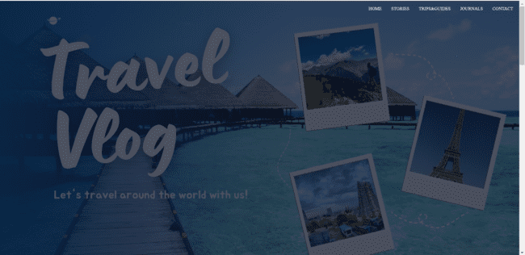

* **Header Section:**
  + The name of the blog is displayed right on the top of the page.
  + A navigation menu is added to link with various sections of the blog such as Home, Travel Stories, Tips and Guides, Gallery, Contact.
  + The header section will be displayed in all the pages and is kept fixed for easier navigation
* **About Me Section:**
  + This section of the home page describes a brief information about myself and the passion of the travel.
  + It also includes the recent places of the travel and also gives an overview of what can be expected for the blog.
* **Featured Destinations/ Latest Blog Posts:**
  + This part highlights the favorite travel destination along with a small description .
  + It also contains links to some of the latest blog posts with a description to make the user view them.

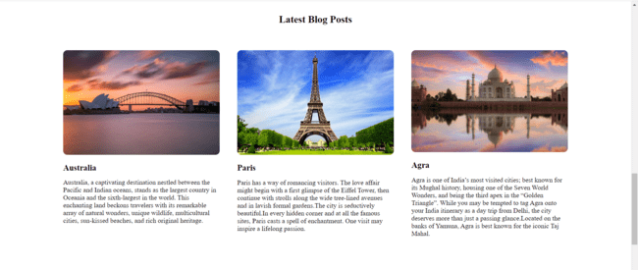

* **Comments:**
  + This part allows the users of the travel blog to post a comment about their experience. And the comments entered by the users are saved in the IBM DB2 database using the Flask app. This comments part is included in all the web pages of the web site.

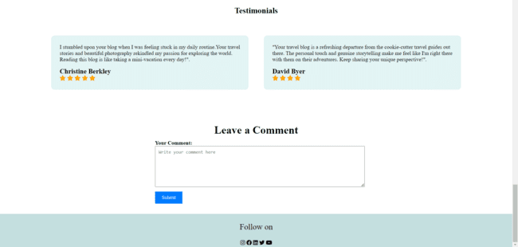

* **Social Media Icons:**
  + Different social media icons are linked to the blog to follow on various platforms. This is included in all the pages of the website



**STORIES:**

This page provides a comprehensive overview of various places that have been visited and links to the pages of corresponding destinations when selected.

We have also included an image map that is interactive, when a particular place is clicked it will redirect to the blog regarding that location.

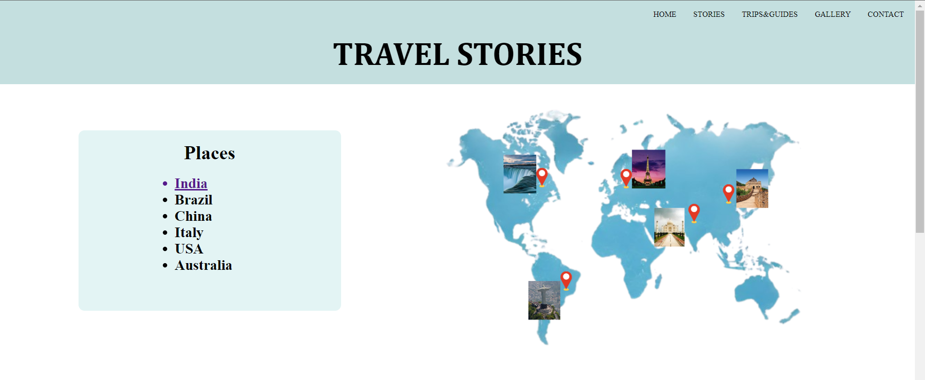

**Destinations Page:**

These pages can be viewed by clicking any one of the places of clicking the place in the map beside. Here we have routed to each destination page using Flask. Each of the destination pages contains the following information.

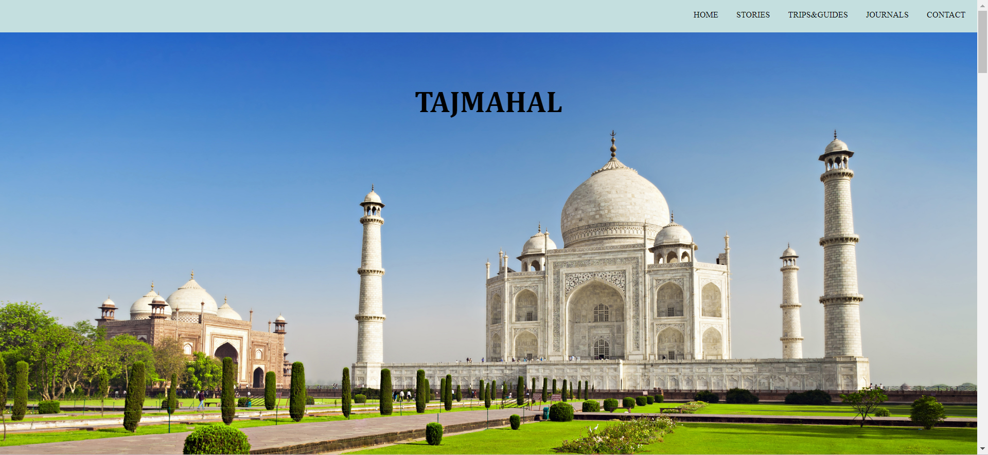

Starting with an engaging introduction to the destination, the page provides a brief

overview of what makes this place special and why readers should be interested in it.

* **Travel Highlights:**

This part highlights the key attractions and landmarks in the destination. It includes must-visit places, iconic sights, and unique experiences that the location offers.

* **Cuisine and Dining:**

This section describes the local cuisine, popular dishes, and dining experiences in that place. It also recommends restaurants or street food stalls where readers can taste authentic local flavors.

* **Activities and Adventures:**

It lists and describes various activities and adventures available in the destination.

* **Accommodation Options:**

This section provides information on different types of accommodation available, such as hotels, hostels, guesthouses, and vacation rentals. It also mentions about any unique or boutique accommodations.

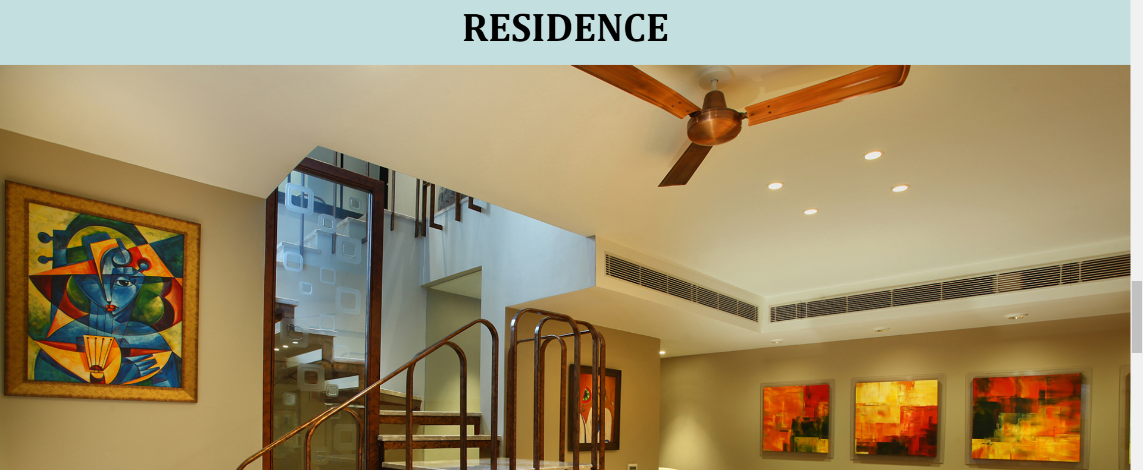

* **Photographs and Visuals:**

Enhance the page with a gallery of high-quality photos showcasing the beauty of the destination. Visuals help readers get a sense of the place.

* **Interactive Maps:**

It includes interactive maps that highlight key points of interest, recommended restaurants, and accommodations. Readers can use these maps for planning.

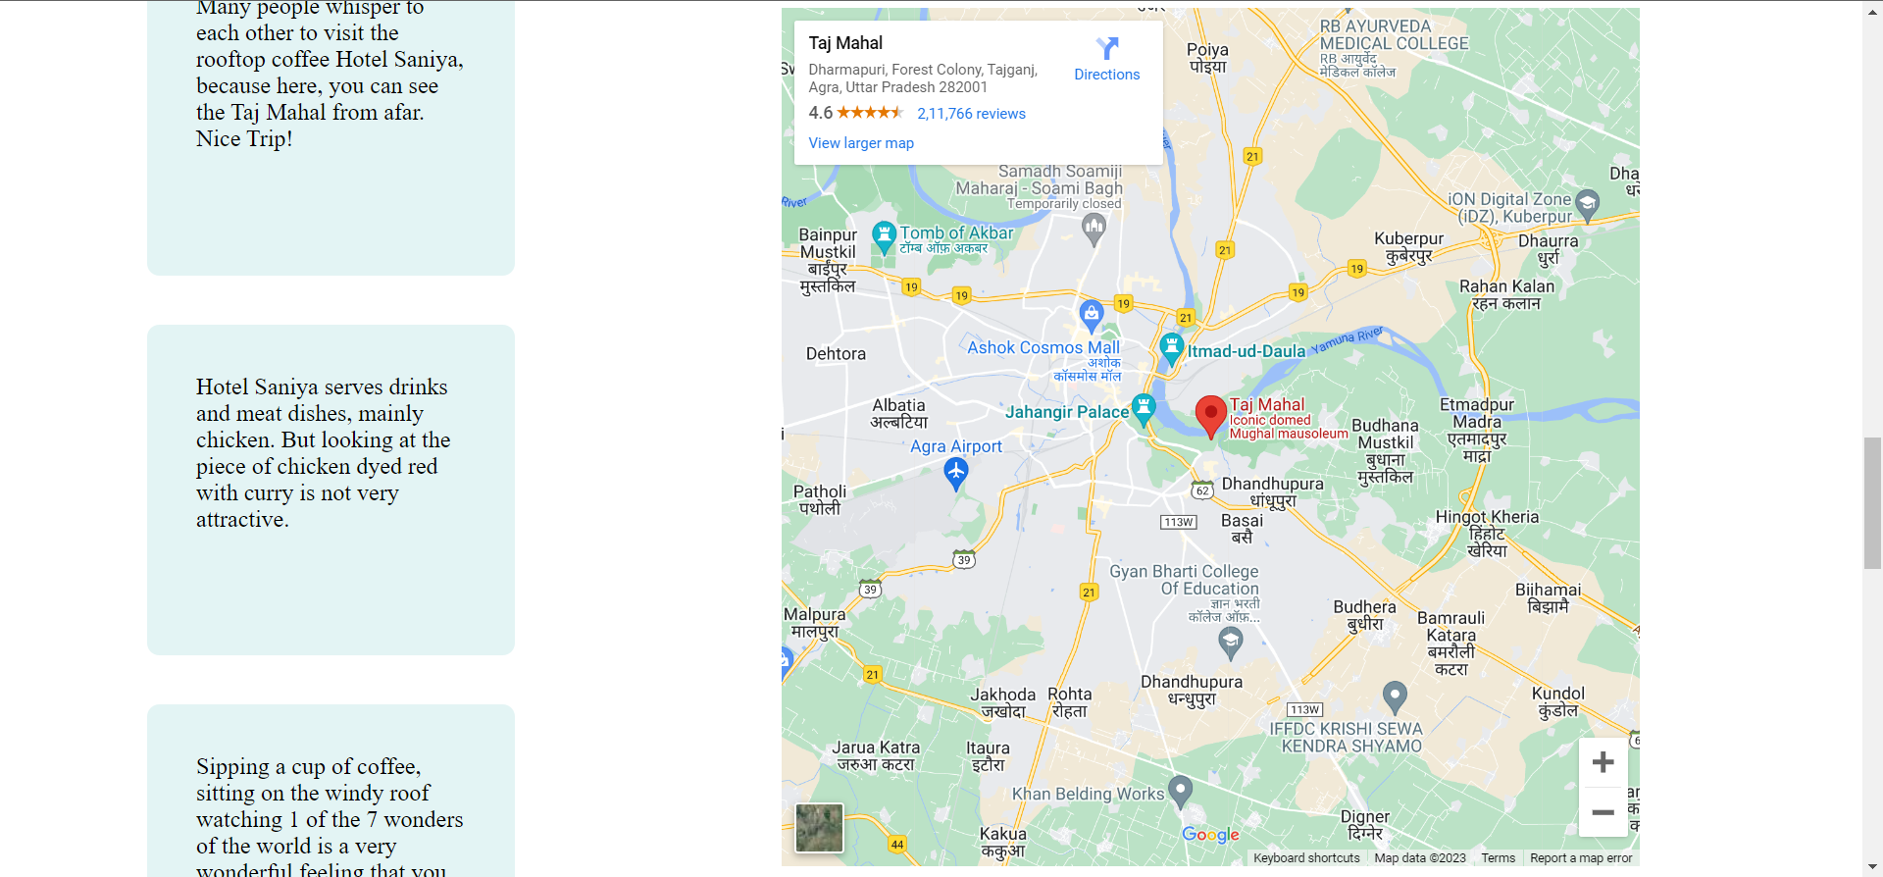

* **Links to Related Blog Posts:** Links to your blog posts that specifically cover the destination. This allows readers to explore your detailed travel stories about the place.

**TRIPS AND GUIDES:**

In this page we have displayed guides for various places which were visited. The guide will help travel enthusiasts to know more about the destination. Initially this page displays various destinations for which the travel guide is present. When a specific location is selected the corresponding guide will open. Routing is done using flask.

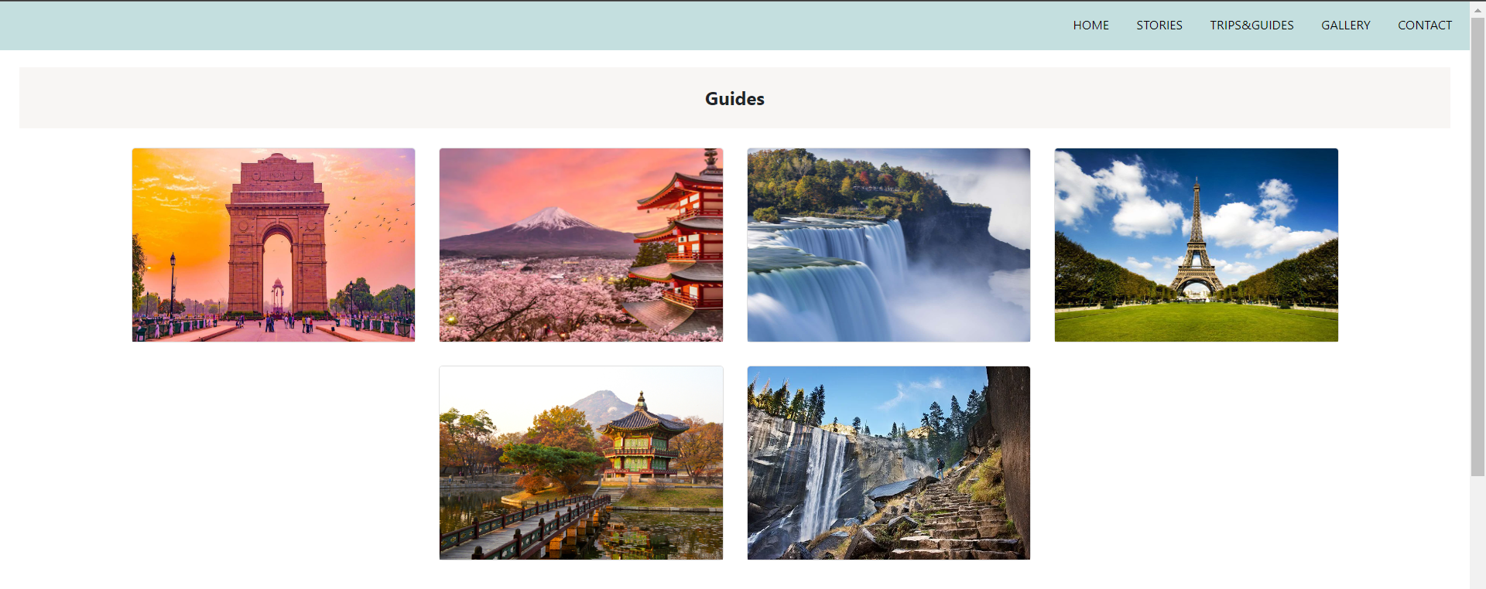

**Guide page:**

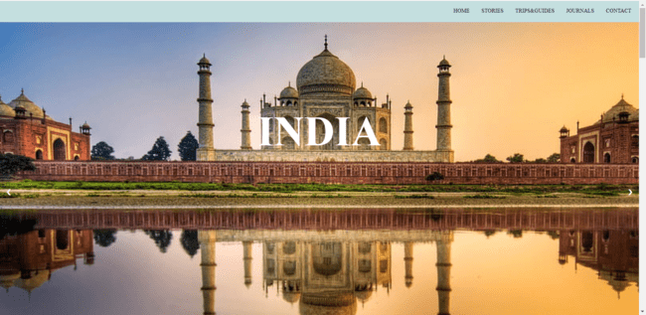

* **Introduction:**

First a brief description of the page is provided.

* **Key facts:**

Here short facts of the country such as Language , Currency, Climate, Capital are displayed along with some icons. The data related to the country are fetched from the IBM DB2 cloud database using flask.

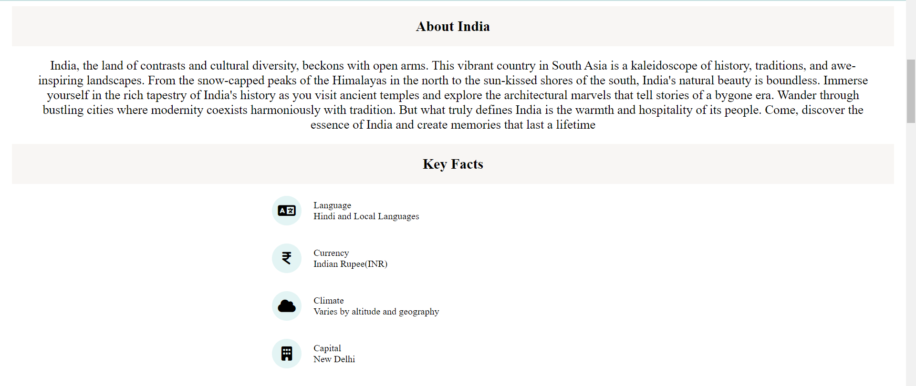

* **Top Destinations:**

A gallery of images of top visited places are displayed which when clicked displays the respective blog post.

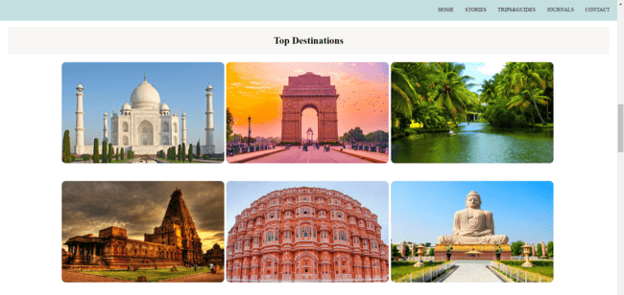

* **Travel :**

This part specifies how to get around the country . It specifies the various effective methods that can be used for travel within the country.

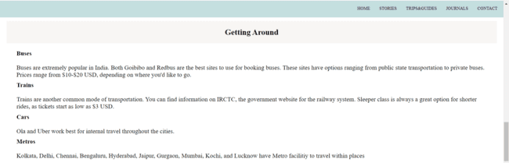

* **Food :**

Here the popular food of the country are described. This may help the travelers to experience the delightfulness of various foods all over the place.

* **Travel tips:**

It specifies some tips for traveling around the country.

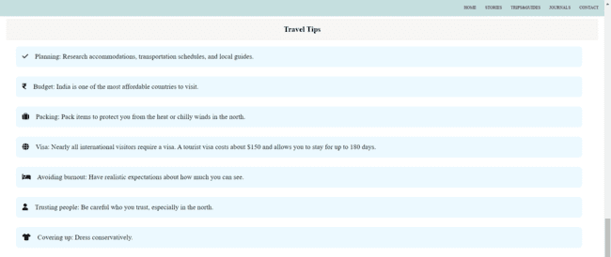

**GALLERY:**

The gallery page has stunning photography of various places. A sample of two places is displayed here.

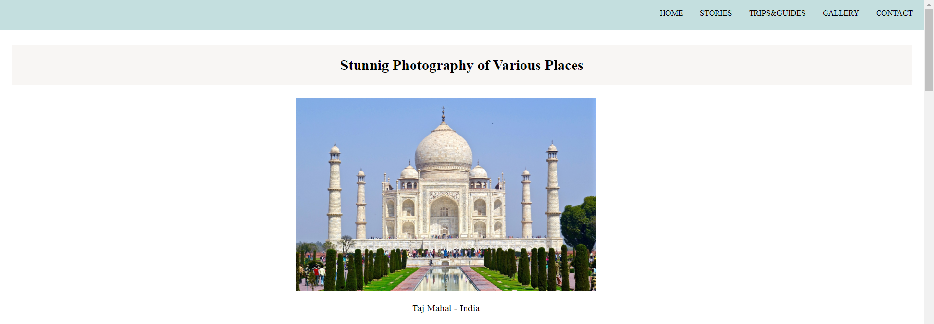



**TECHNICAL IMPLEMENTATION:**

**IBM CLOUD:**

We have used the DB2 database from IBM cloud to store various information related to web pages.

**Steps to create DB2 in cloud,**

1. Select the DB2 service from the list of services available
2. Create a database instance
3. In that database, navigate to load data and upload the table structure as a csv format and go to next step
4. Then create a table and edit the columns as required.
5. Then finally the data will be loaded on to the cloud.

Connect with the cloud using flask (python) by giving the credentials of the cloud account. To obtain credentials, navigate to the credentials tab in the page and click on create new credential if there is not a credential available. In that all the information such as username, password, host, database name will be present. This is used in python to connect with the cloud.

**Library used for connection:** Python has a built-in library called **ibm_db** for connecting with IBM cloud Database. This library is used to perform all the operations related to database such as retrieving data and storing data.

**DATABASES:**

Databases are used to store various kinds of information in the form of tables that can be retrieved later. Using database help us to dynamically update the contents in the website.

Databases are created using IBM Cloud DB2 .

Using the steps provided above create database and table

The database that we used are as follow,

**TABLE: DEST**

**Table description**

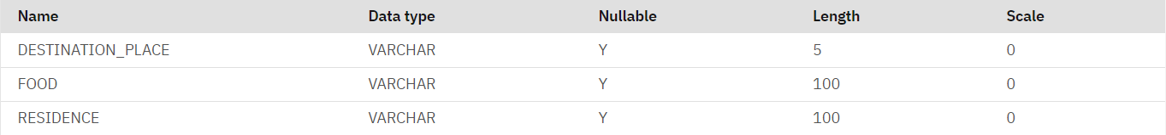

**Table data**



**TABLE: KEYFACTS**

**Table description**

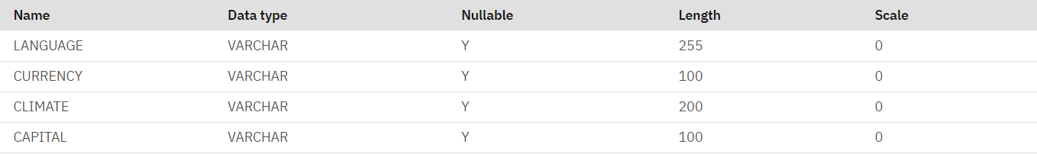

**Table data**

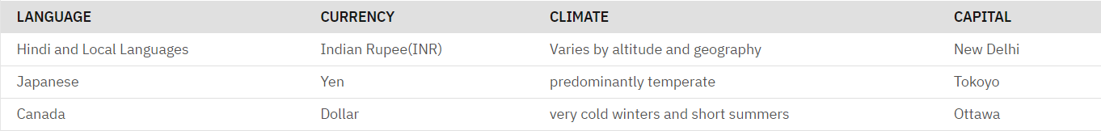

**TABLE: COMMENT**

**Table description**



**Table data**

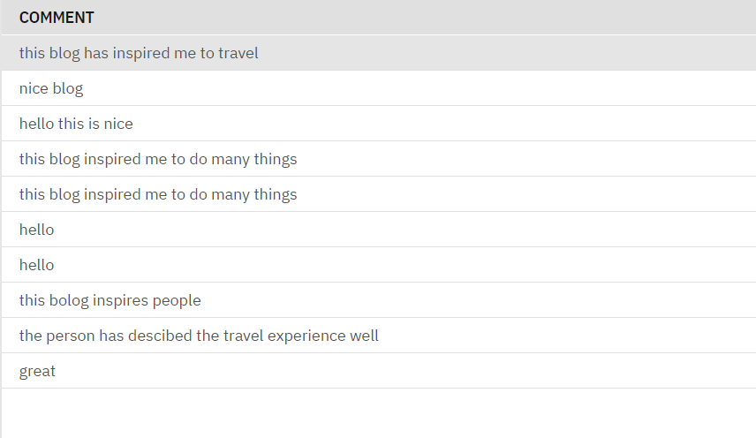

**FLASK APP :**

* Flask is used to generate dynamic content for web sites. It communicates with databases, APIs, and other data sources to retrieve and present information to consumers.
* Flask is used to construct and execute online forms, which let users to submit data and interact with the application.
* Flask is used to create bespoke dashboards for corporations and organizations to monitor and analyze data.
* Flask can be combined with technologies such as WebSocket to create real-time web applications such as chat applications and live data dashboards.
* Flask is used to develop custom content management systems (CMS) for websites.

Flask is a web framework that allows to build lightweight web applications quickly and easily.

In the travel blog the flask is used for the following,

* Connection to IBM DB2.
  + The **ibm_db** library is used.
  + The ibm_db contains method for performing operations on database
  + **connect() method :** This method is used for establishing a connection. The parameters required to connect with the database : hostname,user id,password, driver, database name, port, protocol and security.
* Performing operations with databases.
  + It has various methods to perform different operations with databases.
  + **exec_immediate() method:** This method is used to execute the queries .It takes two parameters - the query to be executed , and the variable used for establishing connection.
* Proving routing among the web pages.
  + All web pages are linked together, using flask.
  + Initially when the code is run the home will be displayed and from that page using the navigation bar all the other pages can be accessed through the routing provided in flask.
  + **@app.route(“/id”) :** This statement is used to provide the routing . For the initial page (home) there will be no id, only the backslash (“/”) is enough. For the rest of pages after the backslash provide a name through which the routing will be performed .

After this statement define a function and provide a return statement **render_template(“filename.html”)**

**For example :**

**In flask file**

@app.route("/travel")

def travel():

return render_template("travel.html")

**Routing in html**

<section class="header">

<nav>

<div class="nav-links"id="navLinks">

<ul>

<li><a href=**"/"**>HOME</a></li>

<li><a href=**"/travel"**>STORIES</a></li>

<li><a href=**"/guide"**>TRIPS&GUIDES</a></li>

<li><a href=**"/gallery"**>GALLERY</a></li>

<li><a href="CON.html">CONTACT</a></li>

</ul>

</div>

</nav>

</br>

</section>

**Organisation of files for implementing flask**

Create a folder travel_blog inside it create 2 folder .

Save the app.py inside travel_blog

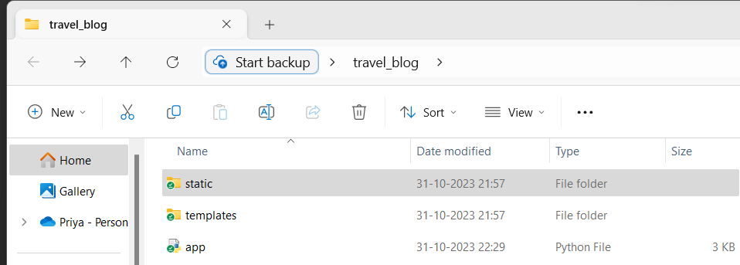

Inside the templates folder include all the html pages

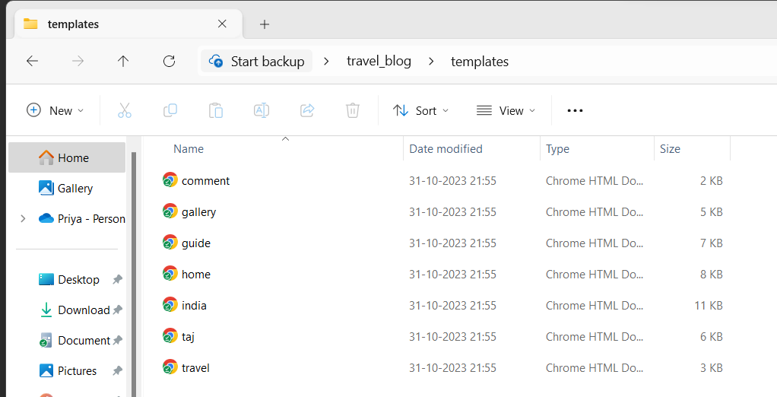

Inside the static folder create 3 other folder for css, images and js

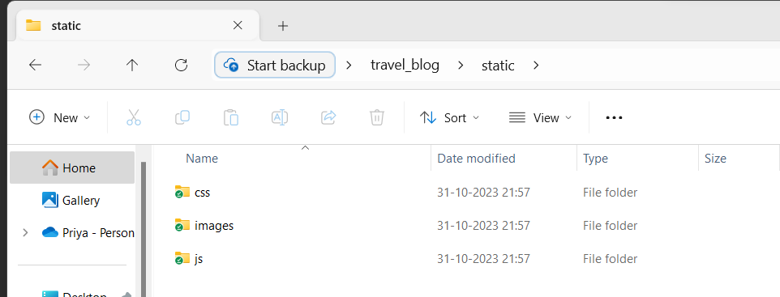

In the images folder all the images that are used in website are loaded

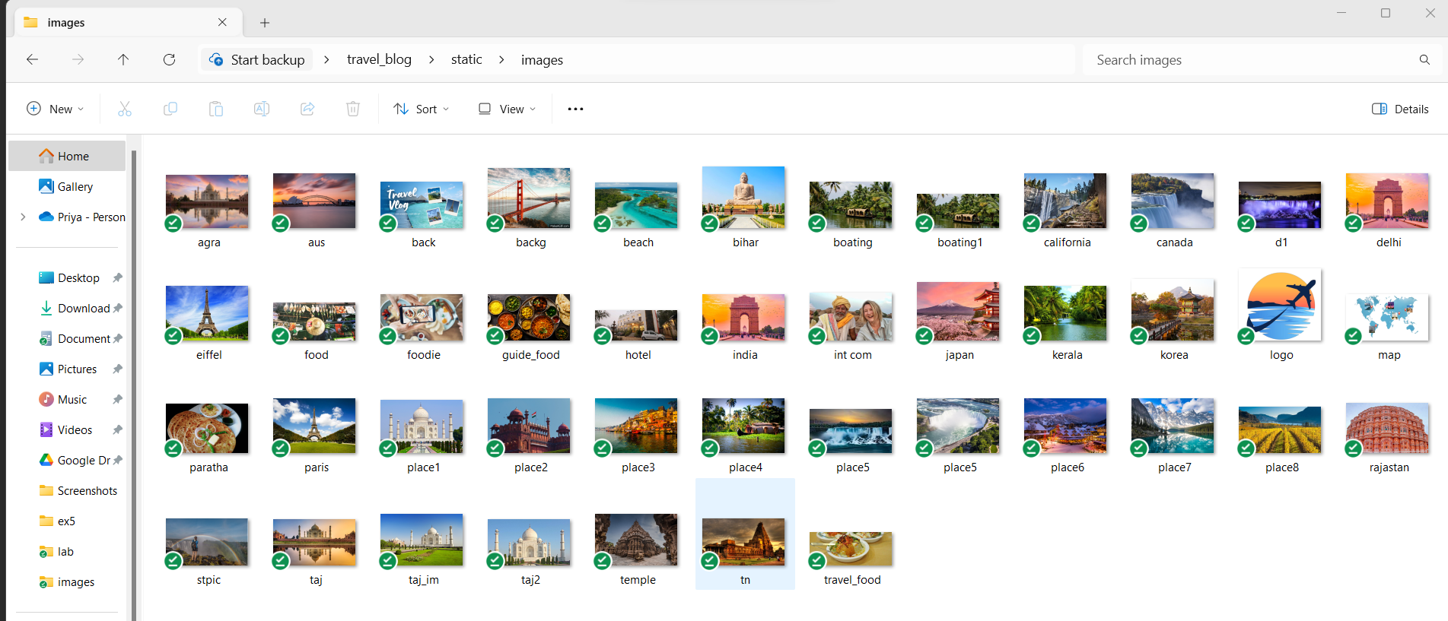

In the css folder the styles related to the web page are saved

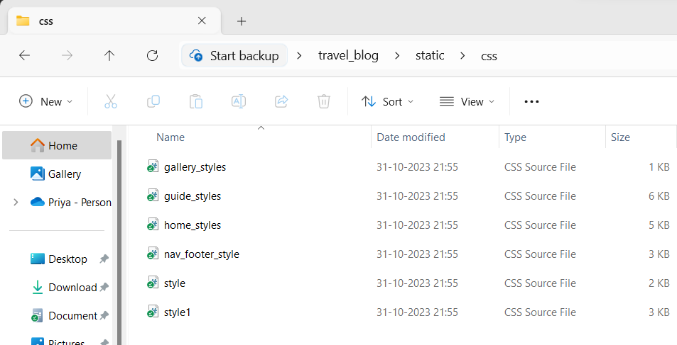

Similarly in the js folder the related java script files are saved

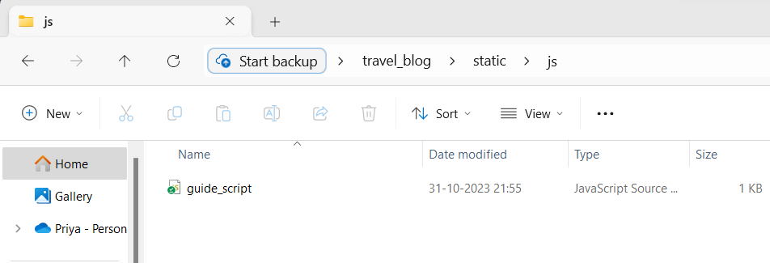

**LAYOUT IMPLEMENTATION:**

The layout of the travel blog is implemented using HTML (Hypertext Markup Language) in conjunction with CSS (Cascading Style Sheets). HTML is responsible for structuring the content on a web page, while CSS is used to style and position the elements to create the desired layout.

Various styling are used to make the website attractive and position things. Many css features such as hover, animations are used.

In the pages , JavaScript is use to provide more interactivity to the website.

The Jekyll is used to append stylesheets.

**DEPLOYMENT:**

**DOCKER FILE:**

A Dockerfile is a text document that contains a set of instructions for building a Docker image. Docker is a platform for developing, shipping, and running applications inside containers, and Docker images are the blueprints for containers. A Dockerfile specifies how an image should be constructed, including what operating system or base image to use, what software to install, and how to configure the image.

FROM python:3.11.1

WORKDIR /travel_blog

COPY . /travel_blog

RUN pip install -r requirements.txt

EXPOSE 5000

CMD python ./app.py

**requirements.txt**

flask

**Step to deploy :**

1.Create a docker file

2. Built the docker image

3.Run the docker image

4.Use Kubernetes

5.Deploy in cloud

**JEKYLL:**

Jekyll is a popular static site generator (SSG) that allows you to build and maintain websites with ease. It is written in Ruby and is well-known for its simplicity and flexibility.Jekyll supports Markdown, a lightweight markup language, for content creation. This makes it easy for users to write content without extensive knowledge of HTML.

Jekyll is often used in conjunction with GitHub Pages, a hosting service provided by GitHub. This combination allows you to easily host and publish your Jekyll-based site directly from a GitHub repository.

While Jekyll is versatile enough to build various types of websites, it is particularly popular among bloggers. It offers features for managing blog posts and categories.

{{ page.title }}

Jekyll uses the Liquid templating language for dynamic content. Liquid tags are enclosed in double curly braces and percentage signs, like {{ }}. You can use Liquid tags for variables, conditions, loops, and other dynamic content within your templates.

{{ key_facts_data[0].get('LANGUAGE') }}